Problem 3: two-dimensional steady convection-diffusion of a compressible flow

Consider the flow of air in a heat exchanger:

v∞ = 0.02 m/s
T∞ = 273 K
T = 373 K
T = 373 K

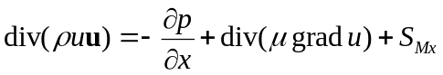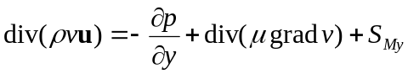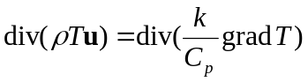The steady flow in the heat exchanger can be described by the following equations:
The viscosity, μ, the thermal conductivity, k and the density, ρ are dependent upon the temperature. The temperature dependencies are already programmed in the computer code. The density is calculated through the ideal gas law:
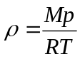
You can place baffles in the heat exchanger through source terms in the routine ‘ucoeff’. See page 267 of the book (page 193 in the first edition) for a full explanation.

Assignment:
Investigate the influence of number, size and position of baffles on the performance of the heat exchanger. Note: the performance involves both the temperature increase of the fluid and the pressure drop over the heat exchanger.

